**MVISION EDR**

*Creating Custom Reaction to Update Registry Keys*

**Copy Powershell Reaction into MVISION EDR Catalog**

Set-Itemproperty -path "{{registrypath}}" -Name "{{keyname}}" -value "{{keyvalue}}"

**Put script into MVision EDR as custom reaction**

Navigate to catalog>reactions

Select Windows>Execute PowerShell Script

Click new then copy script into reaction window

Add arguments Registrypath, Keyname, and Keyvalue and select string.

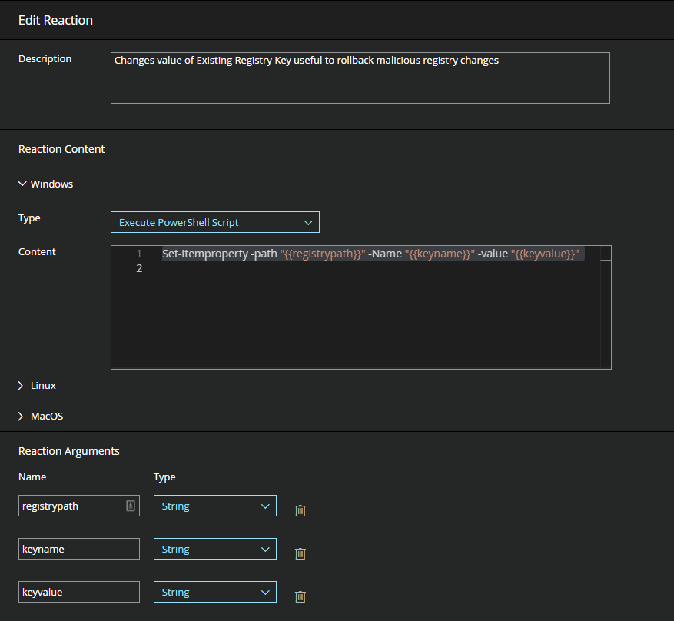

**Executing this Reaction**

Perform a “realtime” search to identify target machines to update registry keys.

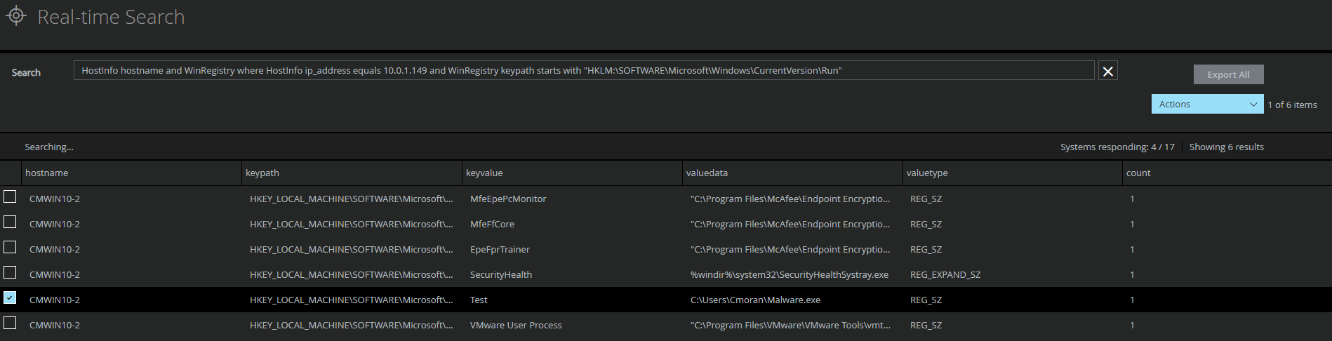

Select the desired machines and enter Registry Key path to update

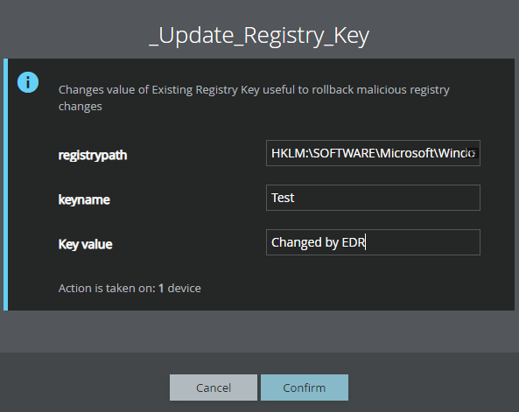

The Registry has now been updated.

